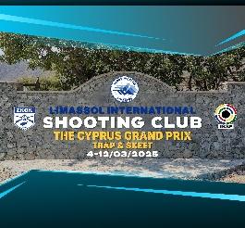***ANNEX 07***

***THE CYPRUS GRAND PRIX***

***TRAP - SKEET***

***04 – 12 March 2025***

***Limassol International Shooting Range***

***Armenochori – Limassol - Cyprus***

***SKEET MIXED TEAM ENTRY FORM***

|  |  |
| --- | --- |
| ***NAME OF TEAM*** |  |

|  |  |  |  |  |
| --- | --- | --- | --- | --- |
| ***A/A*** | ***Surname*** | ***Name*** | ***BIB*** | ***Gender*** |
| ***1*** |  |  |  | Male |
| ***2*** |  |  |  | Female |

***Skeet Mixed teams with athletes of different nations are allowed.***

*No team mixed competition will be established in case the number of participating teams is less than four (4) (in such a case the entry fee will be refunded).*

|  |  |  |
| --- | --- | --- |
| ***Date*** | ***Name*** | ***Signature*** |
|  |  |  |